Date | Class Level  3rd – 6th |  | Subject  S.P.H.E
Strand: MYSELF | Strand Unit: Self Identity • Self-identity • Developing self-confidence • Making decisions • Myself and my family • My friends and other people • Relating to other people
Title: My Super Powers / All about me and the Sea
Objective(s): The aim of the lesson plan is for the children to develop their own ideas about who they are, what they value, as well as their connections with actively caring for the ocean and the marine environment. Using techniques through picture language, the children will gather pictures, photographs and word art to create their own picture portfolio highlighting what they love about the ocean and what is important to them and why.
Skills Required
Developing skills through: • Thinking time • Photo language - using pictures and photos • Circle time • Recording and communicating • Evaluation

Learning Objectives  The child will be enabled to:  Understand and discuss facts about Climate Change and how it is affecting the ocean including:  Become familiar with UN Sustainable Goal 13 – Climate Action  UN Sustainable Goals 14 – Life Under Water  Develop their self-awareness by documenting their ideas and values about themselves and their connection with the environment and the ocean.  Develop their self-confidence in making personal and group decisions towards creating a better and cleaner environment in the classroom, school, home, local community - that will have a positive impact on the ocean. |  | Learning Activities  KWL chart:  Begin the lesson using a KWL chart, where students can track information before and after the lesson. Ask students leading questions from the chart:  - What do you already ‘know’ about this topic e.g. caring for the ocean and its animals and environment?  - What things do you ‘want’ to learn about the topic  - What did you ‘learn’ from doing your research?  Teacher Directed Approach:  - Talk to the class about climate change and the effects of people’s behaviour and connection with the environment is affecting the ocean [and the planet]. For example: although the world has made incredible advancements in the way we live, what we eat, how we travel, and what we do for recreation etc. A lot of the things that have made our lives better and ‘easier’ has at the same time had a direct impact on the environment.  - This as a consequence is creating climate change through increased CO₂ emissions, which is effecting the health of the ocean. Climate Change = Ocean Change.  - Encourage the children to remember that as individuals, we all have unique powers to create positive changes. We have the ability to become more self-aware and learn how our behaviour can affect others and the environment. We can make decisions to lead, innovate and problem-solve to help create positive changes to overcome issues such as climate change.  - The next step is to think about what super powers we each have that can be used to help create positive changes towards protecting and save the ocean from climate change.  Thinking time and photo language:  - Complete the worksheet attached and encourage the students to think about what super powers they have that would help change their behaviour in caring more about the environment and as a consequence helping the health of the ocean.  - Encourage the children to investigate about how their positive behaviour and skills can help other people that are wanting to overcome climate change in their local community (including their family, school and where people might work)?  - Use of photos / ICT / Magazines: Get the children to find photos or pictures in magazines or online that they feel reflect who they are and what they value about the ocean.  - Encourage the children to think about the ‘super powers’ they would like to develop.  Talk and Discussion:  - Using circle time led by the teacher, discuss with the children their super powers encouraging time for listening, oral communication and learning new ideas from each of the children.
Resources
- KWL chart
- All about me and my superpowers worksheet (see below)
- UN Sustainable Development Goals 13 & 14:
  - https://www.un.org/sustainabledevelopment/climate-change/
  - https://www.un.org/sustainabledevelopment/oceans/
- See NASA's Climate Kids Eyes on the Earth website https://climatekids.nasa.gov/menu/big-questions/

Differentiation
Higher and Lower order questioning. Differentiate group activities and roles to account of individual needs, by support, task. Mixed ability pairing.
Assessment
Students: KWL chart (What I know, What I want to know, What I learned)
Teacher observation and questioning: Mind Mapping – colour code what students know / new concepts introduced about climate change and peoples daily behaviour and values towards the environment and health of the ocean.
Examine learning outcomes before and after e.g. children’s knowledge, understanding, self-awareness, confidence, decision making skills.
Evaluation: Reflect on learning experiences that lead to the outcomes e.g. attitudes, enjoyment, as well as motivation to learn about themselves and their connection with the ocean environment.
Linkage and Integration
English – writing stories, learning the structures of plots and understanding characters, writing poems.
Visual Arts – creative drawing creating awareness of line, shape, form; painting using colour, introduce textiles / recycled items to develop texture.
Science / Geography – Environmental awareness and care, caring for my locality / caring for my environment, science and the environment
Geography – Human Environments, People living and working in local areas, People living and working in contrasting part of Ireland, People in other lands (e.g. island nations)
Natural Environments – The local and natural environment, Weather and climate.


We all have super powers! Some are small, some are big!
Tick the boxes below showing which super powers you have.
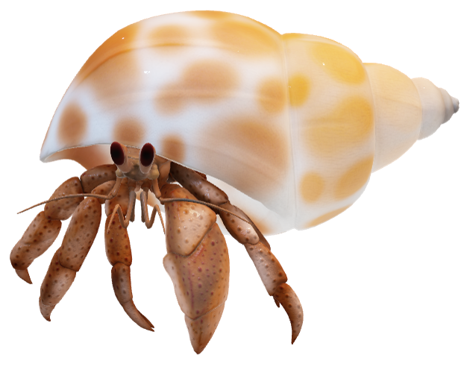
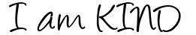
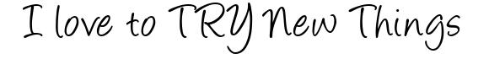
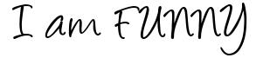
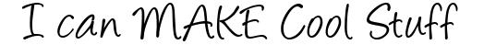
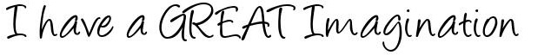
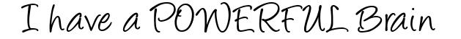
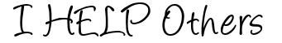
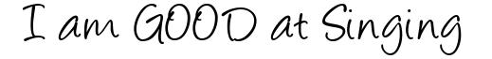
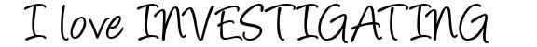
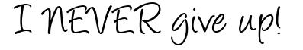
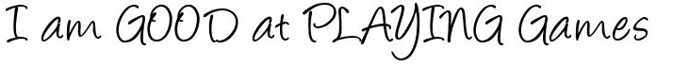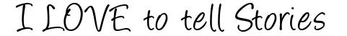
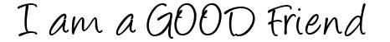
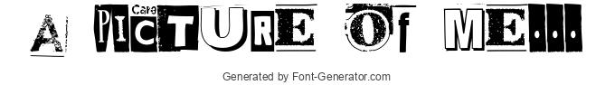
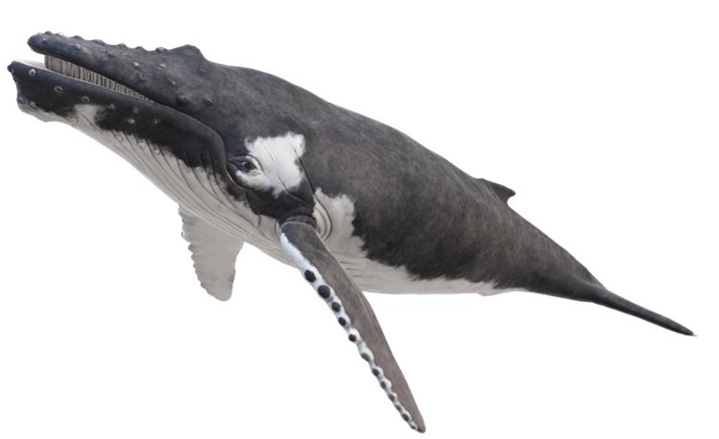

Think about how your super powers can help
care for the environment and protect
our ocean!
Do you have any other super powers?
_____________________________________________
___________________________________________
____________________________________________


